Interview with Anna Alexie
By: Vanessa Lynn Hunter

Elder Anna shares the story of growing up in Nunapitchuk and moving to Bethel in the 1960’s. During her interview, she talked about Bethel then and now, climate change, subsistence hunting and gathering, modern technology, traditional and family values. Alexie now 68 still a Bethel resident still carries her traditional lifestyle. Anna has 3 children and 11 grandchildren. Her encouraging words are respect our land, respect your elders, respect yourself and others.
When Anna first moved to Bethel in the 1960’s she was about 7 or 8 years old. Anna says Bethel changed a lot (she smiles telling her story). Bethel was very small the population was about 300 now the estimated population is over 6000. There was a wonderful American restaurant called the Wild Goose Back then the restaurant was mainly for men to hang out. Later women were able to hang out. She remembers seeing an old fashioned live juke box where people played music. There was also a live band in the restaurant and people danced. Hamburgers were sold for $1.75 with fries, coffee was 5 cents a cup. Back then they only sold root beer and orange soda the cost was about 3 to 5 cents per bottle. Now Bethel has more restaurants mainly owned by Koreans. The cost now for a cheeseburger with fries and a soda is about $16.00. The cost to stay at a hotel was only $20.00 per night today hotels per night is almost $200.00 per person. She remembers rent was one lump sum every month about $300.00 per month. Now some rentals are based on income and could range up to $1700.00 per month. The cost of living here is so expensive. She still lives off the land storing fish, birds, and moose in her freezer. Anna buys the basic needs such as rice, vegetables, seasonings, coffee, tea, sugar, flour and breakfast and juice from the grocery store.
There was only one road here in Bethel. The old hospital was near the new YK building. The AC store and post office was located in the Joe Lomack building. Bethel had 5 stores Swanson’s, AC, and 3 family owned stores which were John Samuelson’s, Joe Mendolla’s, and John Nerby’s. During 4th of July all the stores used to donate apples, candies and apple jacks for prizes. The games were all free it was a lot of fun. We had gunny sack races, 2 legged races and many other games. Most people and kids participated everyone enjoyed 4th of July. Now everything at the 4th of July carnival has to be paid for.
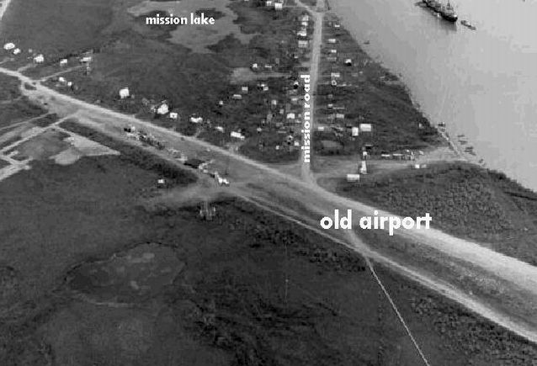
Bethel Alaska photo taken in the 1960’s. University of Alaska Achieves.
Long ago, everything was abundant! All seasons were on time! Winters were loaded with snow. Homes were buried after snowstorms. During the summer of the 1960’s when Anna was about 6 or 7 years old her family used to have a fish camp across the river from the standard oil road in Bethel. After harvesting dry fish for the summer she remembers her grandfather building a huge raft made of logs. They drifted from their fish camp back to her hometown Nunapitchuk. It took 7 days to drift to Nunapitchuk, the raft was so big it carried 6 family members, a dog team, all their food, and their tent where they slept. During the winter she recalls people digging up homes in Nunapitchuk sometimes digging 10-12 feet to get to the door for families to come out of their buried homes. After snow storms when homes were buried they were only able to see their chimneys. Some families had stairs made of snow leading to their door. Summers were beautiful and hot…… peoples fish dried on time. She notices more rain, thunder, lightning including hail storms during the summer. Anna says now winters here in Bethel and the rest of the YK delta have changed over the last 6 years. Just 2 years ago our Christmas was brown. It has been raining in the months of December, January, February and March, our winters are mostly ice now barely any snow. It’s like we switched winters with the lower 48 Anna says.
Anna remembers animals, fish, birds, berries and everything edible were abundant and on time every season. People used to catch a lot of fish during the summer and winter. There was a lot of moose to hunt and feed families. People who had their first catch always shared others in the community. Back then people were very helpful always sharing their catch with others and hunting for families who weren’t able to hunt. Now she says people don’t share their catch like they used to. Now native food is being sold online! It’s all about money now. Seal oil, dry fish, berries, whale blubber, herring eggs, etc. are being sold on Bethel Bargains.
Modern technology sure has taken over. I don’t see kids out playing like we used too. Back in the day was so much fun! Our childhood was physical and healthy. We played lap-game, hopscotch, kick the can and many other games. Kids and teenagers now are on their cell phones playing games, listening to music and playing x-box and wii games connected to the tv. I see people taking walks but there still texting or surfing online or listening to music. She worries about some teenagers losing hearing and having bad vision from using ear phones listening to loud music and watching too much tv.
Some of the traditional values Anna grew up with was faith, advise from elders, respecting each other’s boundaries, honoring your elders, and taking care of others. We grew up going to church and praying, I remember everyone went to service. The Moravian in Nunapitchuk and Bethel used to be packed everyone attended some people even had to have to stand in the porch because it was so packed. We also respected the resting day, everyone in her home cooked and cleaned Saturday and preparing meals for Sunday. Parents and elders used to talk to their kids to behave before playing out. We were taught to respect each other’s, ourselves and to respect our elders.
We grew up with family values too. We played together and worked together as a team. Women were always busy sewing while Men hunted and provided for their families. We respected each other’s, got our chores done before we played outdoors. Anna remembers having family fun playing games during family nights at a center. She grew up seeing women sewing for their husbands a lot. Some women made their husbands 4 pairs of boots. 1 waterproof pair, 1 pair for winter, 1 pair for summer and another pair for indoors. Her family grew up with important family values which was to love, care, respect, praying, keeping tidy, and eating meals together. She sees some family values dying. Some families lack parental guidance and aren’t disciplining or teaching their kids. Children should be guided most of all with love and attention and to be taught what’s right and wrong. Anna’s encouraging words are respect your land, obey your parents, respect your elders, treat others the way you want to be treated, have faith and pray.

