Interview with John Active
By: Vanessa Lynn Hunter
Orutsararmiut Native Council
Environmental Technician
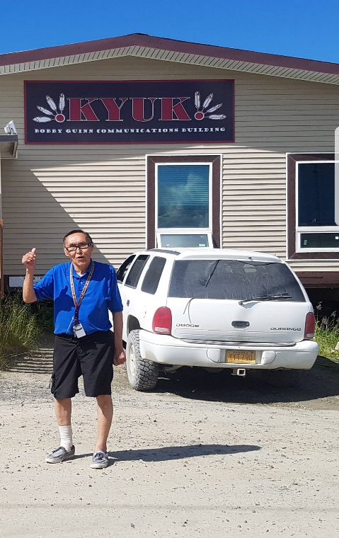
John was born in Cukvvagttulik Alaska to George and Sophie Jacob. John shares his story of being adopted twice after birth and at his early childhood years. How Mamteriileq was formed and why people moved to Bethel including an angry shaman cursing the village of Bethel. Growing up in Bethel back then and now including climate changes. Starting his first job and later working for KYUK. Today John is 69 years old still a resident of Bethel working for Bethels local radio station as a talk show host.
John was born in Cukvvagttulik to George and Sophie Jacob. After I was born my biological mother passed away. My father could not care for me because I was a newborn so he placed me in the care of my uncle Luke Jacob and his wife. But they had kids of their own and could not take care of me. So my father contacted James and Elsie Active of Bethel to adopt me. Right away Elsie flew to Cukvvagttulik to take me and raise.
I spent a lot of time with my adoptive grandparents Maggie and Adolph Lind. I remember when I was about 6 years old a man came in to notify my grandmother that my uncle had a heart attack and fell out of a boat and died. My grandma and grandpa began weeping so I ran to my parents’ house which was right next door to tell them. After my uncle’s burial my grandparents became very lonely losing their only son. My mother felt heartbroken for my grandparent’s so she let them adopt me. I grew up staying one week with my parents and another with my grandparents. I became a blessing to my adoptive grandparents, we sat together reading western cowboy magazines. They used to dress me as a cowboy and I believed was going to be a cowboy when I grew up.
My grandma told me stories of how Mamteriileq started. Long ago during the times of starvation there was a couple from the Yukon who traveled to the Kuskokwim around Bethel. The couple walked and canoed on their long journey. They drifted with the current down passed Kalskag and stopped to rest. The couple set a fish trap they caught a lot of fish and decided to stay. They built their mud house, fish rack, and smoke house. Other Natives saw that this area was a great place to catch fish so they moved there too. People who seen this camp named it Mamteriileq meaning “A place of many smokehouses”. Later Moravian missionaries moved to this camp site to start a church. The missionaries were very kind, they read Bible verses and sang gospel songs to the folks at camp. Back then there was big floods, it flooded so high the whole camp was under water. Everyone canoed to higher grounds, after the water levels went down the missionaries decided to move. There was a shaman who became angry with the missionaries because he did not want them to leave, so he cursed the land wherever they moved. The missionaries found a verse in the bible which quoted “Go down unto Bethel and establish my church their’’ Genesis 35:1. The missionaries traveled to this area built their church and named this place Bethel.
Around 1959 or 1960 when I was about 10 years old, I remember my dad taking me to school by boat because the towns roads were covered in water. Especially during the spring time and during the fall we had big floods. Our school was a log cabin it was built high off the ground to keep our school from being flooded inside. For fun me and my friends used to play along the riverside we pretended we were climbing mountains on the mud. Not long later the river started caving in and the land started sliding. The old graveyard site was located at mission road near the river and the coffins started sliding off into the river. My dad James helped people in our community pull up the graves, even removing human remains from the coffins that opened up and placed them in small boxes. They moved the gravesite which is the graveyard across from the tundra center. Photos below are Bethel landslide, pictures of floods, open gravesite on landslide.
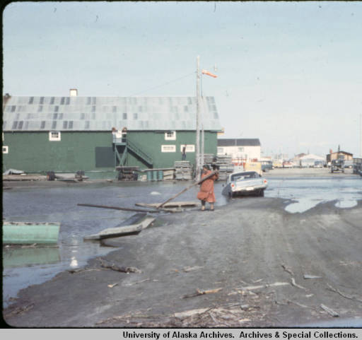
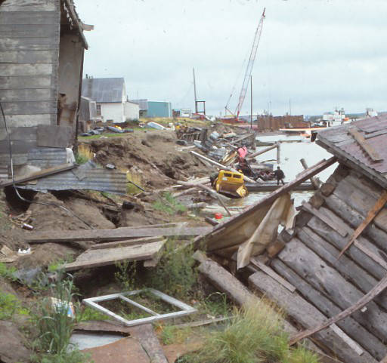
Photo copies from University of Alaska Digital Achieves timeframe 1959-1960

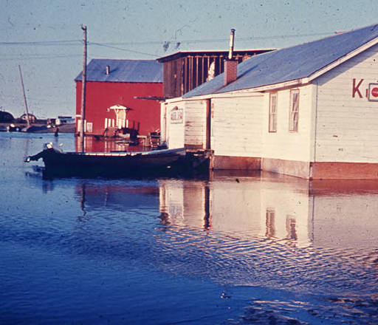
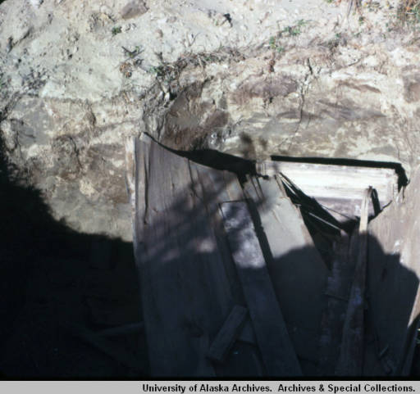
The last minor flooding Bethel experience was May 2012 this did not affect anyone from Bethel but some folks from Napaskiak were evacuated to Bethel. The climate sure has changed over the years, as a kid I remember homes being buried after snow storms. There were so much snow kids built snowman’s and tunnels. Now we don’t have a lot of snow its mostly ice during the winter from freezing rain. Freezing rain makes me worried for the roads being slick this winter we noticed a lot of car accidents here in Bethel. Freezing rain during the winter makes me worried for the animals too. The climate has changed, the seasons are different spring comes earlier and summers seem shorter.
John finished grade school and attended Bethel public school. During Johns senior year he worked for the Bureau of Indian Affairs (BIA) as a secretary. I got to travel to different villages translating in Yupik and helping applicants fill out paperwork for housing and renovation. In the late 1970s I started working with KYUK the local radio station as a Yupik Translator for News. John says his been working for the radio station for almost 40 years”. Johns advice for the youth is “Learn your Yupik language while you can, our elders get frustrated when they cannot communicate with the younger generation’’.

