Welfare Assistance
(General Assistance, Emergency Assistance, Burial Assistance)
General Assistance Program (GA) provides financial assistance payments to eligible Alaska Native and American Indians for the following essential needs:
- Food
- Shelter
- Clothing
- Basic necessary utilities

GA funds are not used for the following:
- Telephone or cellular phone bills
- Eviction and shut-off notices
- Past due bills
- Reconnect fees
- Medical travel
- Funeral travel

Processing time for applications is 1-3 weeks and includes
- Verification of information provided to case worker
- Applicant participation with caseworker in formation of a plan and fulfilling all established deadlines

Eligibility Requirements:
☐The applicant must reside in the service area of Bethel.
☐The applicant must not receive assistance from Temporary Assistance for Needy Families (TANF), Adult Public Assistance (APA), or Supplemental Security Income (SSI)
☐The applicant must apply for assistance from other Federal, State, Borough, or local programs for which they may be eligible
☐The applicant must have documented insufficient resources, to meet the basic and special needs items as defined above
☐All applicants with dependent children are required to apply for TANF

Required Documents:
☐Copy of State ID
☐Copy of Tribal ID, or Certificate of Indian Blood (CIB) card for ALL household members
☐Copies of Birth Certificates for ALL dependent children
☐Current utility bills and receipts from rent and utilities. We do not accept past due bills.
☐Copy of income for ALL household members (earned and unearned) for 30 days prior to the signature date of application which may include:

- Paystubs
- PFD stubs
- Tax Return
- Or other income
- Detailed bank statements for 30 days prior to the signature date of application
Emergency Assistance Program funds cannot be used for transportation, home evictions, etc. Per 24 CRR part 20 sec 20.328. Funds are specifically for cases where a home is destroyed due to fire or flood. Funds are for essential needs and non-medical necessities such as: food, clothing, shelter, and utilities. Approved payment will not exceed $1,000.00
Burial Assistence (BA) funds are for indigent Alaska Native and Native American individuals. A separate application process is involved with BA. Please ask us for an application for burial assistance.
Service Applying for:
☐General Assistance ☐Emergency Assistance
Date:
Name: | Date of Birth:
Social Security Number: | Mailing Address:
City: | State:
Zip Code: | Phone Number:

☐Male ☐Female ☐Single ☐Married ☐Separated/Divorced ☐Widowed
Are you a Veteran? ☐Yes ☐No
If Yes, dates served: to Discharge Date:
Branch:
List all members of your household.
Check the box at the left of each person not included in your General Assistance application budget.
* | NAME | Relationship | Birth Date | Sex | Tribe Enrollment # | Monthly Income
☐
☐
☐
☐
☐
☐
☐
☐

Are there any members of your household with a physical and/or developmental handicaps?
NAME | NATURE OF PROBLEM | TEMPORARY OR PERMANENT | MINOR OR MAJOR | VERIFIED

Current living arrangement: ☐Own Home ☐Rent House/Apartment ☐Rent Room ☐With Friend or Relative ☐Other

Are you or any of your household a shareholder in a Native Corporation (ex. Calista)? ☐Yes ☐No
If yes, list the name of household member and Corporation
NAME | NATIVE CORPORATION | # SHARES OWNED

Have you received TANF in the last month: ☐Yes ☐ No If yes, how much: $
Has your TANF been reduced due to penalties? ☐Yes ☐No Reason:
Have you been terminated from TANF? ☐Yes ☐No Date of Termination:
Have you been determined ineligible for TANF? ☐Yes ☐No Reason:
Have you been denied TANF? ☐Yes ☐No Reason:
Are you eligible to reapply for TANF? ☐Yes ☐No Date to reapply:
What TANF office did you receive assistance from?

How you have supported yourself during the past three (3) months and what has changed in your situation to cause you to apply for assistance? Failure to complete this section will render this application incomplete and it will not be processed.

Do you have an Individual Indian Money (IIM) account? ☐Yes ☐No
Monthly Income
SOURCE OF INCOME & RESOURCES |  | AMOUNT | NAME OF HOUSEHOLD MEMBER
Salary #1: Applicant’s Income/Salary | $
Salary #2: Spouse’s Income/Salary | $
Tips or Gratuities | $
ATAP – TANF – ASAP (State Assistance) | $
Child Support and Alimony | $
Foster Care Payments | $
Adult Public Assistance (APA) | $
Social Security (SSA RETIREMENT) | $
Supplemental Security Income (SSI) | $
Disability Insurance (SSDI or private ins.) | $
Alaska State Permanent Fund (PFD) | $
Cash outs of Retirement or Pension Plans | $
State Longevity | $
Veteran’s Benefits | $
Unemployment Insurance Benefits | $
Worker’s Compensation | $
Food Stamps | $
Medicare/Medicaid | $
Native Corporation Dividends | $
Checking Account (provide statement showing bal.) | $
Savings Account (provide statement showing bal.) | $
Student Loans/Grants/Scholarships | $
Bingo or Pull Tab Winnings | $
Other Income | $
ONC-LIHEAP | $
TOTAL MONTHLY INCOME | $

Current Month Expenses
Rent | $ | Telephone | $
Space Rent | $ | Water | $
Mortgage Payment | $ | Sewer | $
Electricity | $ | Household Oil/Fuel/Wood | $
Heating | $ | Other | $

ACKNOWLEDGEMENTS

I am applying for financial assistance/services for the listed members of my household who are in need. I have received a copy of and have had explained to me, and understand the provisions of Federal Law governing fraud.
Applicants or recipients who knowingly and willfully provide false or fraudulent information are subject to prosecution under 18 U.S.C. §1001, the Federal Law concerning fraud which carries a fine of not more than $10,000 or imprisonment of not more than five years or both.
I agree to supply information regarding resources and income and to notify the agency of any changes in my situation.
I have read or had explained to me the provision of my protection under the Paperwork Reduction Act and the Privacy Act.
Knowingly representing or withholding information to qualify for assistance is Fraud and may result in more than $5,000.00 in fines, imprisonment of five (5) years or both. As well as a reimbursement of funds obtained from this program.
I certify that the information contained above is complete and accurate to the best of my knowledge. I understand that I am signing this statement under penalty of prosecution if I knowingly give false information, which results in assistance received for which I am not eligible.
RELEASE OF INFORMATION
The undersigned authorizes the release of information requested by the Orutsararmiut Traditional Native Council (ONC) General Assistance Program. The requested information shall be used solely in the administration of General Assistance and will not be released to any other person or agency outside the General Assistance Program or its agents. I hereby authorize ONC to obtain and exchange information related to my applications to participate in their programs. And, to arrange for such participations based on my employability assessment and plan to employment related activities. This release of information shall be in effect while I am an applicant or recipient of General Assistance, and for any later investigations pertaining to my eligibility and receipt of General Assistance benefits.
A reproduction of this release is as valid as the original; to be used indefinitely for the present time and future eligibility verifications.

Name of Applicant:

Applicant Birthdate:

Last 4 Numbers of SSN:

Signature of Applicant Date

477 Department Staff

Date Application Received:

Application Received By:

DECISION OF APPLICATION:
☐Approved ☐Denied Date:

Review Dates:
1 month review

3 month review

6 month review

Comments/Notes:

Caseworker:
Date:

TRIBAL ENROLLMENT VERIFICATION
Used only when no other verification forms are accessible.
Printed Name:
Maiden, Other names known by:
Date of Birth:
Last four number of Social Security Number:
Are you a Bethel Native Corporation Shareholder or a Descendant of a Shareholder? ☐Yes ☐No
Are you an ONC Tribal Member? ☐Yes ☐No
If yes, provide ONC Tribal Enrollment Number:
If No, please provide the following information:
Tribe Name and Address:

I have been a Bethel resident since:

LANDLORD/SHELTER VERIFICATION
This form certifies that the below named individual resides at the address indicated below and is responsible for paying the amounts listed below. Applicant must attach proof of payment (receipt, check copy, etc.)
Landlord Name:
Contact information (phone, email, etc):
Business Name and Address:
Applicant Name:
Physical Address:
Payment amount: Frequency of Payment:
Are utilities included in the rent amount: ☐ Yes ☐ No
Cost of electricity (provide current bill):
Cost of Heat/Oil/Fuel (provide invoice or delivery receipt):
Cost of Water/Sewer (provide invoice or delivery receipt):

Verification of Employment

Please return verification form to: ONC 477 Department
117 Alex Hately
Fax: 907-543-2639
Email: education@nativecouncil.org
Applicant Name:
Maiden, Other names known by:
Date of Birth:
Last four number of Social Security Number:

EMPLOYER MUST COMPLETE THE INFORMATION BELOW
Position/Job Title:
Salary: $
Start Date:
☐Part Time ☐ Full Time ☐Seasonal ☐ Other:
If Seasonal, what are the seasonal dates of employment?
Season Start:
Season End:
Are special work clothes or equipment required? ☐Yes ☐No
If yes, is the employee responsible for purchasing the required clothing and tools? ☐Yes ☐No
If yes, please list type of clothes needed:
Supervisor Name and Title:
Contact phone number:
Employer Name and Address:

Date:

TANF VERIFICATION
To Whom it may conern:
The client named below has applied for Welfare Assistance (General Assistance) from the Orutsararmiut Traditional Native Council. Per 25 CFR Part 20 (the Federal Regulation which governs the Welfare Assistance program) all applicants with minor children are required to apply for TANF and must follow TANF regulations. In order to complete the application process, information is needed from your program regarding the client’s current TANF status. Please fill in the information requested on the form below and return to us in one of the following methods:
ONC 477 Department at 117 Alex Hately
Fax: 907-543-2639
Email: education@nativecouncil.org
A Release of Information form has been signed by the client and is included with this request form.

List household members included on the TANF Application
Full Name | Relation to head of household | DOB | Sex | Last 4#’s of SSN

Application received date:

Application status:

Notes:

TANF Representative Name:
Date:

INDIVIDUAL SELF-SUFFICIENCY PLAN (ISP)
CASE PLAN per 25 CFR Part 20
☐ISP ☐Case Plan
Client Name:
Date of Plan:

Identify barriers to achieving self-sufficiency
☐ Physical Health
☐ Mental Health
☐ Substance Abuse
☐ Dependency
☐ Age Factors
☐ Disabilities
☐ Lack of Transportation
☐ Limited Transportation
☐ Education
☐ Criminal History
☐ No Job Skills
☐ No Driver License
☐ Social Isolation
☐ Limited/No Jobs Available
☐ Homeless
☐ Other:

Identify Strengths:
Steps needed to achieve self-sufficiency.

☐ Job Search
☐ Volunteer Work Experience
☐ Job Shadow

☐ On the Job Training
☐ Employment Counseling
☐ Registration with Local Job Service
☐ High School Diloma
☐ GED
☐ English as a Second Language
☐ Adult Vocational Training
☐ Literacy Improvement
☐ High Education
☐ Life Skills Activities
☐ Child Support
☐ Substance Abuse Treatment
☐ Counseling
☐ SSA Application
☐ Medical Report
☐ Decision Letters
☐ Legal Assistance
☐ Child Care
☐ Job Readiness
☐ Driver License Reinstatement
☐ Dental/Health Care
☐ Other:

SELF-SUFFICIENCY ACTION PLAN & GOALS
Client Goal #1:
Goal Revised:
Action Steps:
Deadline:
Completion Date:
Client Goal #2:
Goal Revised:
Action Steps:
Deadline:
Completion Date:
Caseworker Activity (25 CFR 20.318):
Deadline:
Completion Date:
I understand that the purpose of the Individual Self-Sufficiency Plan (ISP) is to meet the goal of employment through specific action steps and I am required to follow the steps developed in the ISP.
I understand that I must participate in work activities and/or other activities and referrals developed in this plan that will promote my self-sufficiency.
Failure to follow through with the ISP may constitute suspension from the General Assistance Program for a period of at least 60 days but not more than 90 days. I also understand that if there are any changes to be made that I will contact my Case Worker in a timely manner to ensure my success in the General Assistance Program.
I understand that the purpose of the Case Plan is to follow through with goals listed: (i.e.) accessing other resource programs, keeping medical appointments, etc.
Failure to follow through with the steps identified in the Case Plan may constitute suspension from the General Assistance Program. This plan is a working document to ensure the applicant and the caseworker have a clear plan set to ensure a cooperative effort to complete goals which meet the needs of the applicant.
This document is signed only at the conclusion of the eligibility interview.

Signature of Client Date:

Signature of Case Worker Date:
Work Search / Work Related Activities

Name of Applicant:
Last four of SSN:
DOB:

Applicant: Please read carefully. Ask your Welfare Assistance Case Worker to clarify if you do not understand any of these requirements.
If you do not complete the work searches, you will not receive GA.

- All employable adults in your household are required to apply for a minimum of twelve (12) different jobs for the month that you have applied for Welfare Assistance.
- You must complete six (6) work searches within two weeks from the date of your application.
- The remaining six (6) work searches must be completed before the end of the month in which you applied.
- Actively looking for work is one of the goals in your Individual Self-Sufficiency Plan (ISP).
- Take the Work Search form to various businesses and submit an application for employment. The potential employer must sign and date the Work Search form which verifies that you have applied for work. Return the Work Search forms to the Welfare Assistance Worker.
- You may also show proof that you are actively participating in work related activities such as obtaining a GED; doing consistent volunteer work; working with Job Service to develop your resume (work history). Provide proof to your Welfare Assistance Case Worker of these activities within two weeks of the date of your application. The proof is a document from the place where you are doing these work-related activities.

Date of your application:

First 6 worksheets due:

Last 6 worksheets due:

DECLARATION OF NO INCOME
Every adult over 18 years of age living in the household must read and sign this if not receiving any income.
With my signature below, I do hereby declare that I have not received any income for the past 3 months of:
Month Name:
Month Name:
Month Name:
The reason I have had no income for the months listed above is as follows; how I’ve been able to support myself and my family:

Printed Name and Signature of adult Date

Printed Name and Signature of adult Date

Printed Name and Signature of adult Date

Printed Name and Signature of adult Date

Printed Name and Signature of adult Date

Employer or Human Resource Representative must fill in appropriate fields below.

Name of Applicant: ______________________________________________________________

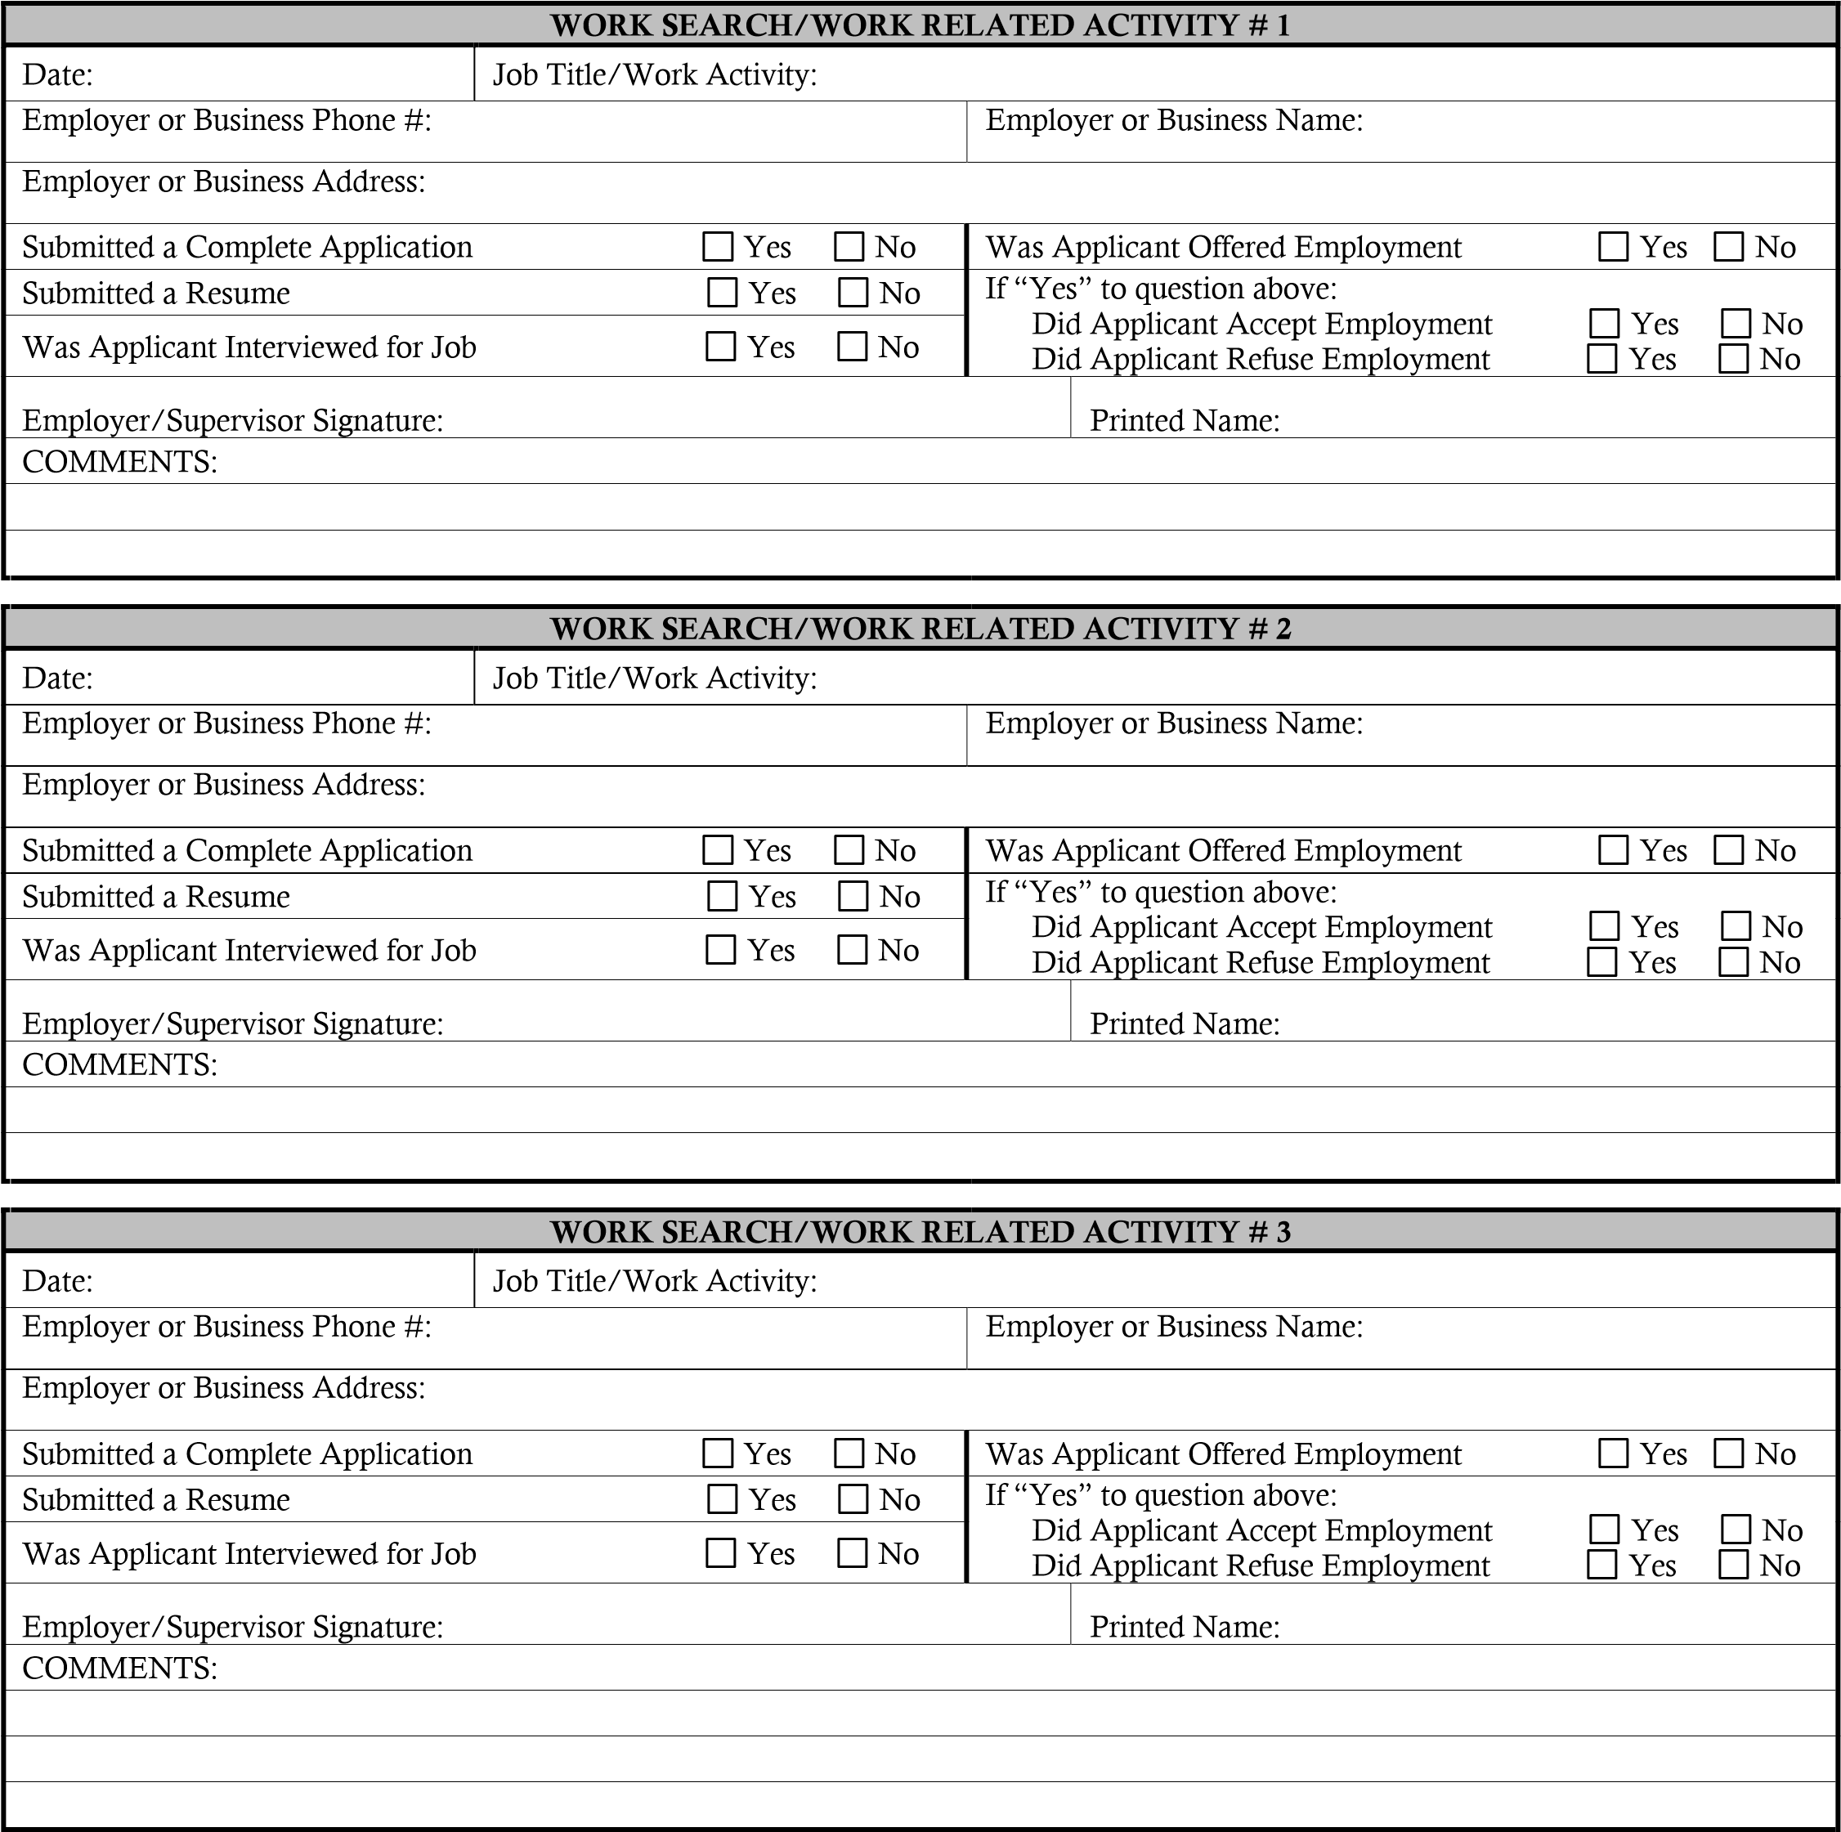

Employer or Human Resource Representative must fill in appropriate fields below.

Name of Applicant: ______________________________________________________________

Employer or Human Resource Representative must fill in appropriate fields below.

Name of Applicant: ______________________________________________________________

Employer or Human Resource Representative must fill in appropriate fields below.

Name of Applicant: ______________________________________________________________

