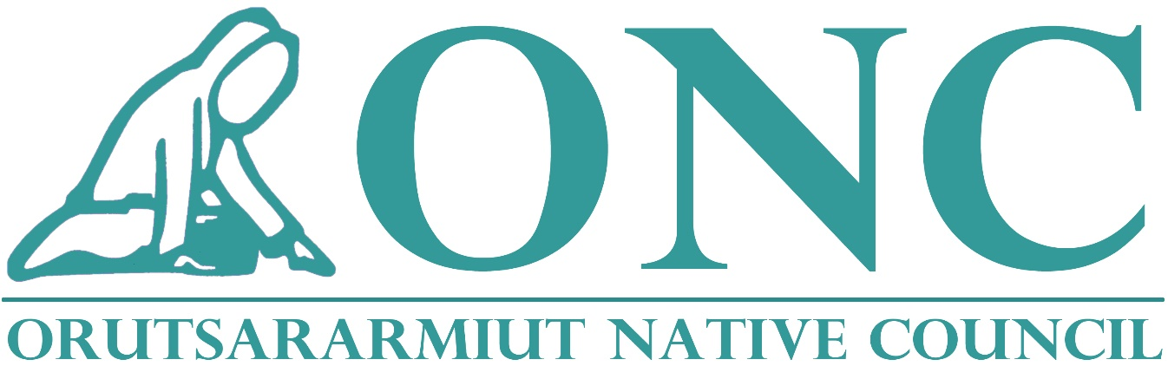

Bethel, Alaska
Public Law 102-477
Three-Year Plan
January 1, 2019-December 31, 2021

Contents
1.0 INTRODUCTION 3
2.0 PROGRAMS TO BE INTEGRATED 3
3.0 CONSISTENCY WITH THE ACT 3
4.0 GEOGRAPHIC DESCRIPTION 4
5.0 ELIGIBILITY 4
6.0 ECONOMIC CONDITIONS 4
7.0 DESCRIPTION OF SERVICE POPULATION 6
8.0 CLIENT SERVICES 6
9.0 RIGHTS AND DUE PROCESS 13
10.0 AGENCIES INVOLVED IN THE DELIVERY OF SERVICES 14
11.0 PERFORMANCE STANDARDS: 14
12.0 REPORTING 15
13.0 INFORMATION MANAGEMENT SYSTEM 15
14.0 WAIVER REQUESTS 16
15.0 PROJECT REVENUE FOR CY 2019 - 2021 16
16.0 PROJECTED EXPENDITURE FOR CY 2019 - 2021 16
17.0 Appendices: 17
- Child Count Declaration
- Child Care Program Assurances and Certification
- Standard Form 424 - Application for Federal Assistance
- Indian Health Service AI-AN 0-12 year old report
- Grievance Procedure
- Performance Measurement Procedure
- Organizational Chart
- Tribal Resolution
- Map of ONC Region - Service Area
- Indirect Cost Rate Agreement
- Audit Report
- Child Care Sliding Fee Scale
- Child Care Program Health and Safety Requirements for Providers
- State of Alaska Market Rate Survey

1.0 INTRODUCTION

The Orutsararmiut Native Council (ONC) PL 102-477 Plan is consistent with “The Indian Employment, Training and Related Services Demonstration Act of 1992”. The effective date of this Plan is January 1, 2019, with no set termination date. This Plan is attached to our Self-Governance Compact and is an amendment to previous plans.

ONC’s Employment, Education and Training Department will administer our Plan under the PL 102-477 Program to (1) improve the effectiveness of current services, (2) reduce joblessness in Bethel, Alaska and (3) better serve ONC’s tribally determined goals, consistent with our policy of self-determination. The integration of employment, training, and related services programs results in comprehensive coordination and administration of funds, reduction of administrative costs by consolidation of administrative functions, with maximum impact to the people we serve.

2.0 PROGRAMS TO BE INTEGRATED

The formula-funded federal programs to be included in the ONC P.L. 102-477 Plan for CY 2019-2021 are as follows:
    - Department of the Interior
Job Placement and Training
Higher Education
Johnson O’Malley

    - Department of Labor
Workforce Innovations Opportunity Act (WIOA)
Adult Comprehensive Services
Supplemental Youth Services

    - Department of Health and Human Services Child Care Development Fund (CCDF)

3.0 CONSISTENCY WITH THE ACT

ONC’s mission is to create and maintain a comprehensive program to provide opportunities to our participants through the provision of education, training, and employment services for Alaska Natives and Native American people residing within the Bethel Region, regardless of where they are from. Our mission is carried out through the consolidation of federal education, training, and employment programs, and related services included in our 477 Plan. This plan demonstrates how we as a Tribal Government integrate these federal program activities and services to improve their effectiveness and reduce unemployment in our communities as we serve organization goals that are in accordance with our strategic plan and the policy of self-determination. Our mission is consistent with the Statement of Purpose of Public Law 102-477.

4.0 GEOGRAPHIC DESCRIPTION

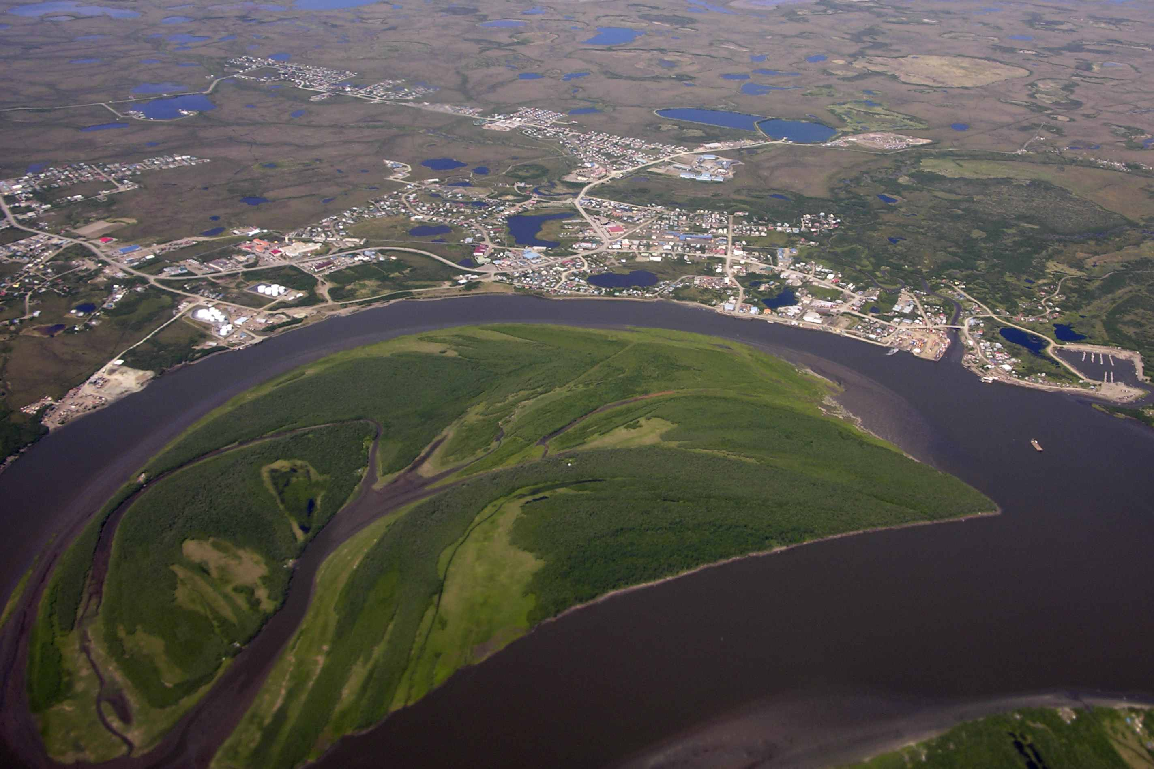
Bethel is located at the mouth of the Kuskokwim River, 50 miles inland from the Bering Sea. It lies in the Yukon Delta National Wildlife Refuge, 400 air miles west of Anchorage with no roads connecting to other communities. The only way in and out if Bethel is by airplane or small watercraft. Bethel is the regional hub for 56 surrounding villages. The community lies at approximately 60.792220° North Latitude and -161.755830° (West) Longitude. (Sec. 09, T008N, R071W, Seward Meridian.)

5.0 ELIGIBILITY

The Orutsararmiut Native Council is the Federally recognized governing body for the community of Bethel, Alaska. This recognition is per Federal Register/Vol.6, No. 49/Monday, March 13, 2000/Notices for the community of Bethel.

6.0 ECONOMIC CONDITIONS

Bethel is surrounded by 56 villages with populations ranging from less than a hundred to over 1,000. Due to lack of infrastructure and employment opportunities as well as depressed economic conditions in these rural areas, the migration of Alaska Natives into Bethel continues to rise each year and is projected to steadily increase over the next decade. The percentage of the American Indian and Alaska Native population has increased from 61 to 65 percent.
Bethel no longer has a commercial fishery, leaving construction as the only major seasonal employment option. The unemployment rate of American Indian and Alaska Native population in Bethel is an estimated 13.9%.
Employment opportunities are relatively high in Bethel; however, the high-grossing salary, executive, and high-skilled occupations require an applicant hold a trade, certification, or college degree to obtain these positions. Many of these vacant positions in our community have been, and continue to be filled by applicants from outside of the Bethel area. The importation of individuals to our community is a major contributing factor to our high property rental prices. The demand for housing increases too quickly for the availability of properties to rent. When you add this cost to the already high cost of fuel (between 4 to 6 dollars a gallon for unleaded), high grocery prices ($8 for a gallon of milk) the cost of living here becomes astronomical. According to the Alaska Department of Labor, the unemployment rate held steadily around 15% for the last three years, and as high as 18% in 2014.

Employment opportunities in Bethel include State and Federal Government offices such as the Department of Transportation, Alaska State Troopers, Fish and Wildlife Offices, the City of Bethel Offices, Public Works, the Yukon Kuskokwim Heath Corporation Hospital, the Lower Kuskokwim School District, Bethel Youth Facility, Yukon Kuskokwim Corrections Center, Yuut Elitnaurviat, two radio stations, telephone and cablevision offices, a few general merchandise and grocery stores, the Alaska Village Electric Cooperative, apartment complexes, several restaurants, the Tundra Women’s Coalition, an automotive parts store, auto mechanic shops, two lumberyards, the Bethel Family Clinic, three fuel service companies, two banks, a credit union, law offices, several hotels, a community college and library, several air taxi and cargo facilities, a video store, and many taxicabs.

Despite the wide variety of employment opportunities available in the Bethel area, competition for employment has increased in recent years. The demand for more qualified individuals increases with the changing economy. Future employment opportunities in this region include tourism, small businesses, certified teachers and other school administrators, commercial pilots, law enforcement officers, biologists, geologists, doctors and nurses, and many other positions that require degrees or certificates.

The seasonal job cycles contribute to difficulties many Alaska Native and American Indian families experience in establishing a stable home environment and substantial work history not only in Bethel but in other communities within our regional service area.

7.0 DESCRIPTION OF SERVICE POPULATION

Based on the Statistical Reports from 2017, our 477 Program has served the following demographic population:
Gender: 66% female 34% male
Age: 64% under 21 (not including those in child care)
36% age 22 and over
Education level: 0% are High School drop-outs
42% are Students
58% graduated High School or earned the G.E.D.
10% have skill training or Post-Secondary education
In addition to the high cost of fuel, rent, and groceries, most of our Native population lacks dependable child care, and the financial resources to ownership of dependable transportation. Bethel has more cab drivers per capita than any other city in the country, but the cost of taking a cab every day to and from work and to lunch and back is far from economical; costing a person $20-$60 depending on where they live. The municipal government has deployed a bus line, but not everyone can use this mode of transportation if their available work hours do not coincide with its hours of operation.
In addition to the stressful, competitive job outlook our participants in Bethel face, the vast majority have a serious lack of skills, training, or work experience to meet the qualifications for the jobs that would enable them to sustain their families without some form of assistance. For those who meet minimum qualifications, they are unfamiliar with proper job interview skills and most do not have a resume. In many cases, the assistance is not only financial, the responsibilities of moving a family from a rural village to the city of Bethel is riddled with unknown, unforeseen challenges, even for those who have lived in Bethel for a generation or more. The number of families nearing their time limit on TANF is high with others constantly at risk of returning to assistance. For parents that have never worked outside the home, the need for work-related activities is enormous. For participants who are working but still low-income including those at risk of returning to assistance, the need for skills training is even greater. And because our participants are younger and younger, the risk of reaching the 60-month maximum under TANF is occurring at earlier ages as well.

8.0 CLIENT SERVICES

Orutsararmiut Native Council is the Tribal Governing Body recognized by the Federal Government for the Native Village of Bethel, Alaska. The community of Bethel, Alaska has a total population of approximately 6,219 people, which consists of approximately 65.0% Alaska Native. The traditional Yup’ik practices and language remain predominant in the area. Subsistence activities and commercial fishing are major contributors to residents' livelihoods. According to the U.S. Census data for Year 2010, the median household income was $86,935, per capita income was $29,220, and 7.8 percent of residents were living below the poverty level.

ONC will continue to utilize the following comprehensive strategy to alleviate the situation regarding the high unemployment rate, and to continue to address other barriers to employment issues that continue to plague our Native residents of Bethel.

Under this PL 102-477 Plan, the single application will be utilized with a menu type system to make available, various employment, training, and related service programs to our Native participants.

The services an individual participant actually receives under this menu system will depend on that particular person’s needs and individual Employability Development Plan (EDP). The services included in our menu, and a brief description of these services and the special considerations that will apply to each, are listed below:

8.1. EDUCATION AND TRAINING SERVICES

  - Remedial or Basic Education for those participants not ready for a GED program.
  - GED Preparation for youth or adults or an Alternative School Approach for those youth who do not have a high school diploma.
  - Post-secondary Education
  - On-the-Job Training
  - Combined Activities: participants may be simultaneously or sequentially enrolled in two or more program activities. Reimbursement may be up to 100 percent to employers, including private-for-profit employers, for expenditures for the costs of classroom training, employment and training assistance or supportive services. This may also include the costs of participants’ wages paid by the employer for time spent in these activities during working hours. Also, reimbursement may be made on a cost reimbursement or fixed cost basis, and shall be supported by business receipts, payroll, or other records normally kept by the employer.
8.2 ECONOMIC DEVELOPMENT
Employment generating/Job Creation Services. ONC’s PL 102-477 Department has committed to provide services that will result in job creation. As a result, we are involved in economic development activities, which include job specific training and start up implementation of all tribal job creation activities, as well as collaboration with other working agencies to promote economic development. Some of these events include small business workshops, child care conferences, and career fairs

8.3 SUPPORTED WORK SERVICES

This will be considered Work Experience and will include short-term or part-time employment, generally with the public sector or non-profit employers, but will also include the private sector; as such employers are more likely (in this region) to employ Work Experience participants. This service will be aimed toward the youth and young adults, who have little or no work experience, and those families disabled or physically handicapped, who need assistance in finding work or in gaining work skills, such as punctuality, completing work assignments, team roles, etc. Work Experience will be for a reasonable length of time, based on the needs of each participant, but will not exceed 500 hours.

Private sector placement of participants in a supported work component will be allowed only under the following circumstances.

- Short-term placements of participants under a Vocational Exploration Program.
- Placements in tribally owned enterprises will be considered public sector positions for Work Experience purposes.

8.4 CASE MANAGEMENT SERVICES

This will involve the assignment of participants to specific ONC employment and training staff who will provide counseling services when warranted, and will include, on a case-by-case basis, accompanying participants in dealings with potential employers or other service providers.

8.5 OTHER EMPLOYMENT AND TRAINING SERVICES

Training Assistance will include, but not is not limited to the following
  - Outreach – i.e.; job fairs, career fairs, school and community workshops, etc.
  - Assessment and Employability Planning
  - Job Counseling for new entrants and for job retention
  - Job Search and Readiness Assistance
  - Job Referral and Placement Services
  - Orientation to the World of Work (Youth Employment and those new to the workforce)

8.6 SUPPORTIVE SERVICES

- Limited Health Care (such as eyeglasses)
- Temporary Shelter
- Work Tools and Clothing

8.7 YOUTH SERVICES

Youth Services are offered for Alaska Native and Native American Youth. The Youth Employment Services (YES) provides work experience in actual employment settings. Education and Training Services will concentrate on labor relations, resume development, work ethics, rights of employers and employees, and social adjustments in the work places.

Eligibility Requirements
Unless otherwise noted, eligible employment and training participants are Alaska Native and Native Americans, either members of a federally-recognized tribe and/or have a Certificate of Degree of Indian Blood (CDIB) (regardless of blood quantum), or tribal enrollment card noting they are Alaska Native/American Indian and/or show eligibility for Indian Health Service (IHS), residing in Bethel. Eligibility may also be based on income requirements, for example for those who receive TANF or General Assistance, are unemployed or underemployed, income below 70% of Lower Living Standard Income Levels (LLSIL) or have income below the DHHS poverty level for Alaska.

- Participants may be between the ages of 14 and 24.
- Assessment and employability planning services will be provided to all participants and we will provide activities allowed by our granting agency.

8.8 JOHNSON O’MALLEY SERVICES

Non-Indians will not receive JOM Funds
ONC’s Johnson O’Malley Indian Education Committee (25 CFR 273.15) will appropriate how the Lower Kuskokwim School District (LKSD) in Bethel should use the JOM funds. The committee will continue to meet regularly to discuss whether the school district and/or other fund recipients meet the goals of JOM program. The goals will be determined through dialogue and discussion between school district, committee members and observation of the statistics of student success/failure. The committee will collaborate with the school district and director to determine how the funds will be used for direct services which include Native Youth Olympics (where students will gain knowledge of traditional competitive games while gaining cultural pride), craft supply for cultural art, instructor fees, after school reading program, and student tutor/mentor fees.

The drop-out rate has been increasing among students in LKSD and there is an urgent need for immediate and effective action to remedy and alleviate this problem. The goal of the committee is to collaborate with LKSD and parents to arrange programs for students to gain success in school, and address students’ long term needs. Long term needs can be defined as:

- Keeping children in school
- Raising test scores
- Increasing graduation rates
- Reducing drop-out rates

In addition, administration must seek out student involvement/advocate for the following: Funds used for stipend for students or advocate involvement.

- Youth advocate to speak to School Board members on behalf of students
- To gather and provide statistics on student success/failure rates for the JOM Committee/School Board members
- To provide a Case Manager for Native students.

8.9 CHILD CARE SERVICES

Child Care Services are funded by the Department of Health and Human Services and will be administered by ONC’s PL 102-477 Department. Funds will be integrated with our education, employment, and training, and related services. The department staff are directly involved and responsible for providing these services. Activities will be focused on child care subsidies, early childhood development, helping develop jobs for individuals who want to provide child care, to plan the and to improve the quality of child care.

Our subsidy will help parents of eligible Indian Children with access to quality child care as they pursue education and/or training, pursue employment, and/or work for their income, and are engaged in qualified subsistence activities. All our families have the goal of becoming self-sufficient. Our intent is to help them attain this goal. Results expected include the provision of a safe and nurturing child care environment, including early learning, nutrition, and the incorporation of cultural activities into the curriculum.

The Child Care service will provide direct or indirect child care and/or development assistance/services to those participants who need such assistance in order to participate in one of the other PL 102-477 program components. i.e., those participants wishing to utilize Remedial or Basic Education, GED preparation, Occupational and/or Skill Training, On-the-Job Training, Combined Activities, or Supported Work Services. The results expected are that those participants utilizing these program components will gain the education and/or training skills needed to become self-sufficient.

An Indian Child is an individual under the age of 13 who is an enrolled member, or is eligible for enrollment in a Federally Recognized Tribe. Eligible applicants must be Alaska Native or American Indian residents enrolled in or eligible to be enrolled in a Federally recognized Alaska Native or American Indian Tribe living in our Service Area (greater Bethel area).

All eligible Native children will be under the age of 13 (with some allowable special needs children) and reside with a family whose income does not exceed 85% of the Grantee Median Income for a family of the same size and whose parent(s) are working or attending a job training or educational program, or who receive or need to receive, protective services or participating in a substance abuse treatment program.

A sliding fee scale, used to determine each family’s contribution to the cost of childcare, is being utilized and is based on the income and the size of each family. (See Attachment for a copy of ONC’s Sliding Fee Scale).

Special Needs Child is a child up to age 19 who is in Child Protective Service care, is an Indian Child Welfare Case, is physically or mentally challenged, or is homeless.
Parents who are eligible for child care assistance within ONC’s guidelines for childcare services will continue to have the option from the following services on a semi-annual basis:
- Center-based Child Care
- Group Home Child Care
- Family Child Care
- In-home Child care
ONC will continue to coordinate to the maximum extent feasible, with the lead agency in Alaska, particularly Association of Village Council Presidents, Inc., in Southwestern Alaska, who is the region’s lead agency for child care. Coordination efforts with AVCP, Inc. also include Temporary Assistance to Needy Families (TANF) program services. When the TANF program has clients that need child care services in Bethel, they will be referred to ONC. ONC’s regular practice is to refer clients with children to the TANF program in addition to the services we provide. This coordination will result in the family achieving self-sufficiency.
As part of eligibility, clients must provide immunization records for children, using both State and Federal health agencies here in Bethel, AK. These organizations are State of Alaska’s Public Health Service which provides immunizations and the Federal Government’s Yukon Kuskokwim Delta Regional Hospital and its medical records department.

We will coordinate with the State and Federal Health and TANF lead organizations as a means to providing optimum services to eligible applicants and eligible children who receive priority services for child care assistance. (a) Yukon-Kuskokwim Health Corporation will be responsible for provision of health care, including immunizations. Results will demonstrate that all children and providers in the program will maintain good health and will have all required immunizations (b) Education Coordination with school districts and Head Start will result in an environment which assists with early learning. Children with special needs will be identified early and thus can receive the services necessary to ensure their success in school. (c) employment services or workforce development coordination with the 477 Department will result in parental employment which will lead to self-sufficiency. (d) ONC will coordinate with local, regional, and statewide services.
ONC will spend no less than 7% in fiscal year 2019 and no less than 8% in fiscal years 2020 and 2021 to improve the quality of child care services and to increase parental options for, and access t, high-quality child care. This will include continuation of encouraging and supporting the use of Yup’ik language and culture in child care.

ONC will spend no less than 7% of our distributed funds in fiscal year 2019, no less than 8% in fiscal years 2020 and 2021 to improve the quality of child care services and to increase parental options for, and access to high quality child care. This includes the continuation of encouraging and support for use of the Yup’ik language and culture in child care.

All child care providers as well as any other person over the age of 16 living in the home where child care will be provided are required to provide Criminal Backgrounds Checks and fingerprinting, consistent with the Indian Child Protection and Family Violence Prevention Act. Alaska Statute (AS) 12.62.160 authorizes “Any Person” to receive Alaska criminal justice information. Alaska Administrative Code (AAC) further defines procedures to obtain this information. AS 12.62.160 also authorizes the dissemination of additional information to employers and licensing agencies for screening of applicants for positions responsible for the care of children and dependent adults (an "Interested Person"). The subject of a record is authorized to view or purchase a copy of his/her entire record. The Department of Public Safety, Criminal Records and Identification (R&I) Bureau maintains Alaska Criminal Justice Information.

Approved family child care, in home care, and relative providers will be required to become certified in infant and child CPR and first aid. In addition to this certification, all in-home providers will be required to complete online courses that cover topics such as safe sleeping practices, sudden infant death syndrome, medication storage and administration.
Center based child care providers, group home, and licensed family child care providers will be required to be in compliance with all the State of Alaska standards for licensure.

Attached are the child care rates for ONC. ONC ensures equal access as reimbursements to childcare providers are at or above the Alaska’s seventy-fifth percentile of market rate survey that was conducted in 2017, in Southwestern Alaska. ONC’s subsidy service also ensures equal access by allowing families to afford quality center based child care.

Additionally, ONC’s PL 102-477 funds will implement an Early Education “Library” which will include educational materials (including books, puzzles, games, etc.) to be utilized by ONC’s Childcare Providers as most of the ONC’s childcare services are delivered by means of Family Child Care on In-home Child Care. The intent is to attract potential providers who otherwise may not consider becoming a provider due to the lack of material for children in their home.

On a yearly basis, we will survey our CCDF providers to ask what technical assistance/training needs they may have. Unannounced home visits will occur in order to directly observe the quality of care. Quality improvements activities and goals to improve the quality of care include offering both the wed-based and in-person training for providers. We also intend to provide items such as fire extinguishers, gun locks, smoke detectors, carbon monoxide detectors, or we survey our providers yearly and ask them what they may need to improve the quality of care.

Public Hearing: ONC Child Care Services conducted a public hearing on July 6, 2018 (see attached flyer). No comments were received during the public comment period, and no comments were received during the public hearing. Late comments will be considered and if appropriate, a plan revision will be submitted.

Child Care Providers will be licensed by the State of Alaska, when the state requires them. They will also operate under a State Business License when required by the state. ONC will help individuals with the qualifications. If a provider is operating with a Business License, ONC will ensure that they meet the minimal federal standards for prevention and control of infectious disease, building and physical premises safety, and health and safety training. The State of Alaska requires licensing for all non-relative providers regardless of the number of children in their care and for all providers caring for more than 4 children. ONC Staff will assist in monitoring the provider's home to ensure standards are met, and will be responsible for monitoring the provider's home. If we become aware of noncompliance regarding the above categories, ONC will inform the appropriate licensing agency.

ONC elects to exempt the following relative providers: grandparents, great grandparents, aunts, uncles, and siblings who live in a separate residence from the child in care from health and safety requirements. However, relative providers must self-certify that they ensure that the children in their care have all required immunizations and that they take precautions to ensure their home is free of hazards that may cause injury or disease. Guidelines are provided to relative providers. A new provider will be home visited for health & safety of the home and thereafter unannounced visits will conducted. Eligible parents/provider provide the timesheets and we verify the timesheets and paid the provider.

CCDF funds will be used for planning for construction or renovation.

The delivery of CCDF services will be administered under ONC’s PL 102-477, Education, Employment and Training Department, and will continue to comply with all the standard assurances and certifications as attached to this consolidated 477 plan.

All applicable ONC and DHHS criteria and regulations under the CCDF Program will be met prior to the parent(s) receiving childcare assistance under the CCDF Program.

9.0 RIGHTS AND DUE PROCESS

A participant who believes that his/her rights or entitlement have been violated by any Orutsararmiut Native Council 477 Program staff may file a written complaint with the 477 Director. Each step of the appeal/grievance procedures must be followed and filed within a specified time frame or the complaint will be dismissed.

Note: If the participant and interested parties wish to appeal the decision of the grievance committee, he/she may do so by formal appeals process to the Secretary of Labor, U.S. Department of Labor, 200 Constitution Avenue, NW, Washington, DC 20210.

10.0 AGENCIES INVOLVED IN THE DELIVERY OF SERVICES

ONC’s 102-477 Department will be the agency of the Tribal Government directly involved in the delivery of services for program components integrated in ONC’s PL 102-477 Plan. The 102-477 Program Director will report directly to ONC’s Self-Governance Director.

ONC’s 102-477 Department will continue to be the agency within ONC directly involved in the delivery of Higher Education, Job Placement and Training, Direct Employment, Child Care, and Adult Basic Education services.

ONC’s 102-477 Department will be the agency within ONC directly involved in the delivery of WIOA program components, which will continue to include Supplemental Youth Services.

11.0 PERFORMANCE STANDARDS:

ONC will continue to utilize the performance standards developed under its initial Demonstration PL102-477 Plan, which began on January 1st, 1998.

In addition, ONC will utilize the Youth Progress measure for its Supplemental Youth Services Program, in which the students will attain at least two of the following measures: (1) complete job readiness or enroll in a vocational education training program (2) complete career assessment (3) secure unsubsidized employment (4) participate in youth services that result in (a) returning to school, (b) remain in school, or (c) enroll in a vocational training school, (5) improve basic skills by advancing at least two grade levels in reading or math or attain a GED or high school diploma, (6) complete occupational skills training.

Performance standards for ONC’s PL 102-477 Johnson O’Malley Program and its program components, again, will not be applicable.

Performance standards for the following program activities included in this Plan remain the same:
- Measurable
- Outcome Based
- Proven as Workable
- Consistency with ONC’s current PL 102-477 Plan

Performance Standards under this plan will continue to be measured in terms of percentages of the total number of terminees. The three percentage outcomes to be met (or exceeded) are as follows: entered employment, positive termination from the services, enhancement of employability.

Statistical numbers reflected on the annual report will also be explained in the narrative
report, which will provide a more descriptive account of the outcomes.

These performance standards will continue to be utilized as part and parcel of the evaluation criteria to measure successful (or unsuccessful) progress/accomplishments within our PL 102-477 Plan goals and objectives, as well as to promote quality performance within the plan’s confines and requirements.

These Performance Standards will continue to be calculated and monitored on a bi-annual basis. 477 Department staff will continue to take appropriate steps to insure that the performance standards are met or exceeded at the end of the program year.

12.0 REPORTING

ONC will submit a consolidated Annual Report each year to the Office of Self-Governance.

The Annual Report will be in three parts: a Narrative Report, a
PL 102-477 Demonstration Statistical Report; and a Financial Status Report.

The Narrative Report is a summary of the goals and objectives of ONC’s program for the reporting period, and the meeting of each goal and objective. It will describe any problems experienced in the program, and ONC’s strategy and resources needed to address these problems.

It will include numerical information and describe the performance and achievements as measured according to/against the Plan standards.

The PL 102-477 Statistical Report provides a summary of the people participating in and terminating from the program, demographics, the services received and their outcomes.
The Financial Status Report will contain the required financial reporting data under ONC’s 477 project.

13.0 INFORMATION MANAGEMENT SYSTEM

ONC’s 477 Department uses a custom database, designed to capture participant demographic information and information pertinent for program reporting purposes.

14.0 WAIVER REQUESTS
Waiver requests will be processed by the 477 Department Director and tribal administration with the involvement of the Tribal Council, when deemed appropriate.

15.0 PROJECT REVENUE FOR CY 2019 - 2021

Orutsararmiut Native Council
Tribal Programs | Total Budget
BIA Higher Education | $ 165,451.00
BIA Job Placement & Training | $ 48,832.00
BIE Adult Basic Education | $ 2,897.00
BIE Johnson O' Malley | $ 67,739.00
DOL WIOA - Adult | $ 46,835.00
DOL WIOA - Youth Supplemental | $ 15,143.00
DHHS Child Care Development Fund (Discretionary) | $ 198,132.00
Totals | $ 545,029.00

16.0 PROJECTED EXPENDITURE FOR CY 2019 - 2021

Estimated budget per year:
Salaries and Fringe: $179,672.00
Direct Services: $358,601
Supplies: $6,756
Total: $545,029.00

17.0 Appendices:

- Child Count Declaration
- Child Care Program Assurances and Certification
- Standard Form 424 - Application for Federal Assistance
- Indian Health Service AI-AN 0-12 year old report
- Grievance Procedure
- Performance Measurement Procedure
- Organizational Chart
- Tribal Resolution
- Map of ONC Region - Service Area
- Indirect Cost Rate Agreement
- Audit Report
- Child Care Sliding Fee Scale
- Child Care Program Health and Safety Requirements for Providers
- State of Alaska Market Rate Survey

